W04 Final Proposal

Required sections in the proposal document:

1. Overview:
   * What is the problem we are trying to solve?

The problem to solve will be to create a site that offer help technical to agriculture and poultry production activities. It is directed to individuals as well as micro, small and medium-sized companies, which are dedicated to agricultural and poultry production activities, so that they can have the equipment and facilities to increase agricultural and poultry production, which allows them to increase their income, offering technical knowledge and advice, as well as the sale of equipment that increases your productivity and collaborates to improve your financial situation.

* + Why are we doing this?

There are families that have some ownership over small portions of land, and due to lack of knowledge and equipment, their property is not productive or has very low production. What they are looking for is to collaborate to increase technical knowledge in terms of how to increase productivity in their activities and provide them with equipment at costs that allow them to acquire it and through the production and sale of their products they can increase their income and improve their quality of life.

1. Who is the audience?.

The audience is to people that have a small property of land, is dedicate to agriculture, have poultry production activities, or want to dedicate of these activities in profitable way

1. List of the major functions of the application. What will it do? List these in as much detail as you can.

t will have a main page that will present the two main objectives, which are the sale of tools and equipment, as well as technical advice and monitoring of agricultural and poultry production activities.

Regarding the sale of tools and equipment, classifications will be presented such as:

Equipment for construction and maintenance of greenhouses.

Irrigation and water storage systems.

Seeds and seedlings.

Tools for cultivation and harvest activities.

There will also be the necessary subclassifications.

There will be a shopping cart, as well as a chat to ask specific questions about the products and their use.

Regarding advice, there will be sections on topics that are general and there will be subtopics as specific as required according to the problem or area of knowledge to be addressed.

1. Wireframes of the major views (Mobile and desktop...do the mobile wireframes first!)

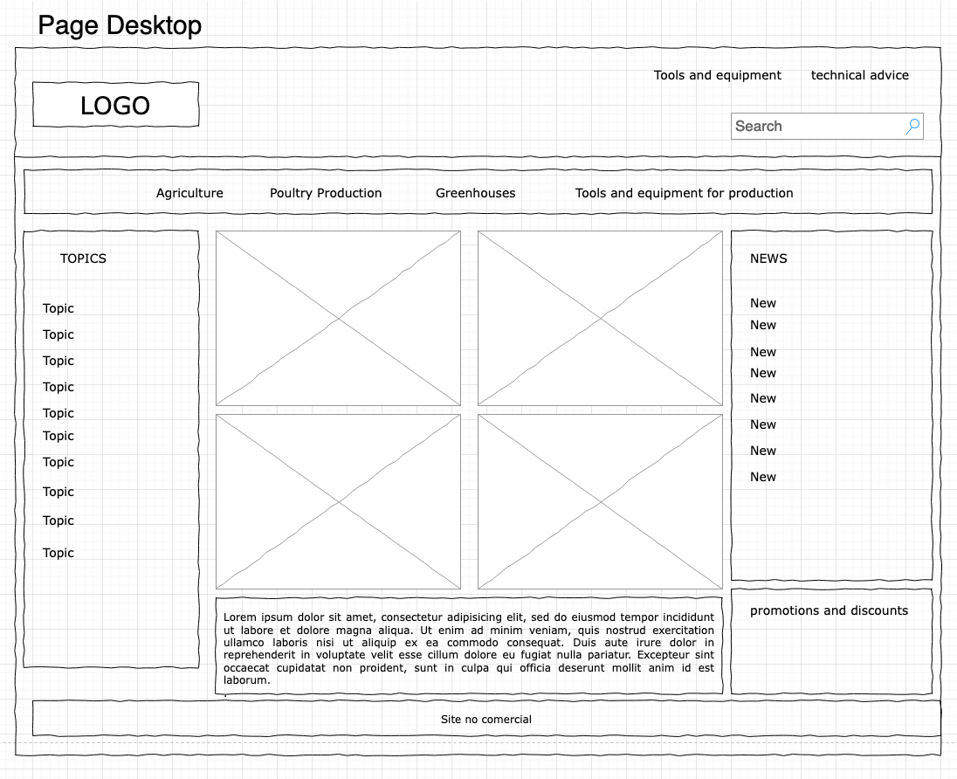

1. Data sources (External API, localStorage, local JSON file, etc.)

The Data source Will be Local JSON files.

1. Initial Module list

The modules will be the following

Equipment: get the equipment of list in JSON files and show in the pages.

Tools: get the Tools of list in JSON files and show in the pages.

Greenhouses: get the greenhouse of list in JSON files and show in the pages.

advice and consultation: get the topics and content of the advice.

sales: management about the sales in the site.

shopping cart: implement the shopping cart.

costumers: implement that costumers can register and do the validation.

1. Colors/Typography/specific element styling

The primary color will be: #1BD94B

The secondary color: #E6A9A9

Typography:

Example:

1. Schedule to provide yourself mile markers along the way to help you stay on target.

1. Link to a Trello board with all the tasks you can think of at this point defined as cards. Again be as detailed as possible here.

<https://trello.com/b/MpfFM5m7/projectgreenhouse>

